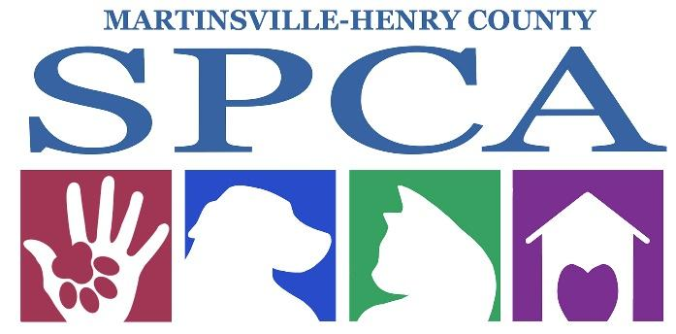

**Martinsville-Henry County SPCA**

**132 Joseph Martin Highway**

**Martinsville, VA 24112**

**(276)638-7297 (PAWS)**

[**www.spcamhc.org**](http://www.spcamhc.org)

**ON SITE VOLUNTEER PROGRAM**

We appreciate your interest in volunteering your time and energy to help us advance animal welfare in Martinsville and Henry County. Together, we can accomplish our goal of being the voice for the animals who have no voice.

Our volunteer program is available to individuals seeking school related volunteer hours, as well as those who just want to make a difference in the life of an animal.

**ABOUT OUR ON SITE VOLUNTEER PROGRAM**

The Volunteer program is for individuals 16 years of age and up who are willing to make a commitment. Due to insurance liability requirements, we cannot approve volunteers under the age of 16 without adult supervision. Anyone under 16 has to have a parent or adult guardian present at all times.

**HOW TO GET STARTED**

Please complete the Volunteer Application and submit it to the SPCA. You will be contacted via email with upcoming shelter orientation dates. Volunteer Orientations are a vital component of understanding how shelter operations flow. Orientation will include a tour of the facility, overview of our operations, and a question and answer session.

If you are unable to attend an orientation, please contact Caroline at Communications@spcamhc.org

**VOLUNTEER JOBS AVAILABLE**

**Cat Companion**

Socializing with the cats in our care is important for their health, wellness, and adoptability. Volunteers play with, pet, and groom our cats, helping them get comfortable with human interactions.

**Shelter Helper**

Help us meet the needs of daily operations by assisting with laundry, dishes, creating enrichment treats, bathing puppies, and sorting donations.

**Kennel Attendant**

Assist with the morning or afternoon cleanings within the cattery or dog runs.  Shifts for cleaning are available every day from 7:00AM to 11:00AM and then again at 2:30PM until 5:00PM. You are welcome to work an entire shift or just a partial shift.

### **Adoption Event Assistant**

### This role primarily involves providing assistance during events, including setup and breakdown of materials. Volunteers are needed to assist with handling canines on leash as well as caring for the cats in crate set-ups. Volunteers under 16 must be accompanied by a parent/guardian.

**Public Relations Assistant**

Help promote the Martinsville-Henry County SPCA by taking pictures and creating highlight videos or content for our social media channels. This may include assisting with writing newsletters for the SPCA, writing (or learning to write) grant applications, graphic design, marketing animals, office administration tasks, or assisting with volunteer orientations.

**Dog Walking and Socialization**

Our dogs are full of energy and love to play with their human friends. Volunteers help exercise our dogs throughout the day every day of the week. You must attend a Dog Interaction Orientation which is separate from the basic volunteer orientation and be 18 years of age or older before working with our dogs.

**Foster Team**

Being a foster parent for a homeless animal is the most rewarding job there is! We are always in need of kind families to open up their home to foster nursing mothers and bottle feeding kittens or puppies. We will send you with all of the supplies you need including food, blankets, bowls, and litter boxes. Sometimes, we receive animals that are too young to be in a shelter environment or medical cases that need more involved care. Fostering is a great way to help us learn more about the animal’s behavior so we can find the best fit home for them.

### **Humane Education Team**

### Humane Education volunteers assist with our Pet Educational Program. Activities include providing lessons and making presentations to classrooms of various aged children, presenting educational programs to community groups, assisting with marketing and program implementation. Therapy dogs and their owners are encouraged to join this team!

**Fido’s Finds and Kittie’s Kollectibles Thrift Store**

Volunteers are needed desperately to assist in our thrift store at 119 E Main Street Martinsville, VA. You will be assigned a shift to assist in the day to day sales, stocking, and maintenance of the store. During basement sales volunteers are always needed to help maintain order, run the register, and answer questions.

**Transport Team**

There are times when we need to transport our animals to a larger facility or adoption center within the state of Virginia and sometimes further. We need your help! We can provide you with a gas card and will load all of the animals safely into crates inside of your vehicle. You will be given instructions on where to meet the rescue and contact information.

We also need assistance in picking up large donations. If you have a truck and or trailer, you are perfect for this job!

**Other Jobs**

We are always open to new ideas and creative ways to help our shelter flow more efficiently. If you have a special skill that you think we could utilize, please let us know!

**SPCA Volunteer Application**

**Please answer every question**

Name: ___________________________________

Phone: (_____)___________________________

Address: ______________________________________________________

City: ________________________State: ____________Zip: _____________

Email: _________________________________

**\*Please be sure to include an email as this is our primary way to contact you about upcoming events!\***

Applicant Age: _______

**Person to notify in the case of an emergency:**

Name: _______________________________________________________

Contact Number: (______)_________________________________________

Please place a check inside of the box beside your areas of interest:

󠄄 Cat Companion

󠄄 Shelter Helper

󠄄 Kennel Attendant

󠄄 Event Assistant

󠄄 Public Relations Assistant

󠄄 Dog Walking and Socialization

󠄄 Foster Team

󠄄 Humane Education Team

󠄄 Fido’s Finds Thrift Store

󠄄 Transport Team

󠄄 Other (Please specify: ________________________________________)

**Volunteer Agreement and Waiver of Liability**

I, ___________________________________, recognize that working with animals at the Martinsville-Henry County SPCA places me at physical risk, and I agree to assume that risk. I understand that the SPCA cares for animals with unknown backgrounds and dispositions. These animals may scratch, bite, or carry diseases and parasites which pose a potential hazard for volunteers and other workers. I realize that although the Martinsville-Henry County SPCA has taken measures to protect me, accidents and injuries may still occur. Therefore, I release the Martinsville-Henry County SPCA from any and all claims and causes of action, including but not limited to, negligence or gross negligence, that I or another might have to or arising from any injury or damage that I could sustain while assisting the Martinsville-Henry County SPCA or in connection with my work for the Martinsville-Henry County SPCA.

I fully understand and agree that I am providing my services in a volunteer capacity without any expressed or implied promise of salary or employment benefits. I agree to perform my volunteer duties to the best of my ability and to adhere to agency rules detailed in my orientation. I understand that my volunteer involvement may be terminated for any reason if I do not meet my commitment in an appropriate manner. I agree that the staff of the Martinsville-Henry County SPCA may assign any appropriate task to me. If I feel the task is not appropriate I agree to discuss this with the Volunteer Coordinator.

I agree that the Martinsville-Henry County SPCA may photograph my participation in this program, and hereby release any such photographs to the Martinsville-Henry County SPCA for use in its programs, publications, or other purposes.

I recognize and agree that I am to act responsibly while working with or while in the presence of SPCA animals and staff. This includes but is not limited to striking or verbally abusing animals, staff members, customers, and other volunteers.

__________________________________ ___________________

*Signature of Volunteer Applicant Date*

**IF YOU ARE UNDER THE AGE OF 18, PLEASE HAVE YOUR PARENT/ LEGAL GUARDIAN PRINT THEIR NAME HERE:**

**Name: ________________________________**

**Phone Number: _(_____)____________________**

Revised 12/2023