Welcome to the Martinsville-Henry County SPCA
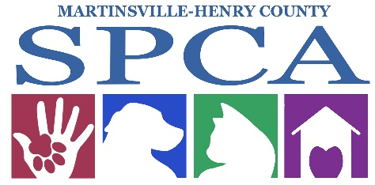

We appreciate your interest in volunteering your time and energy to help us advance animal welfare in Martinsville and Henry County.
This volunteer handbook will introduce you to our mission, vision, and community services we offer. It will also explain some important rules for volunteers. While this information will get you started volunteering with us, some volunteer positions require additional training and time.
We respect your time and skills and will strive to make your experience with us pleasant, productive, and rewarding. Although we do not currently require a monthly time commitment, we encourage regular participation and value dependability in all of our volunteers.
Helping animals in our care is challenging and rewarding. It can also be physically and emotionally draining. Without volunteers, our animals and our mission would be under-served. If you want to see the results from your dedication to these animals, stop by, volunteer, spend time with that scared or fearful dog and watch it walk out of the door wagging its tail. That is what it is all about! We strive to give the homeless animals here the best stay they can have until they go to their new forever home.
After the orientation class, we encourage you to sign up for your primary areas of interest such as dog walking, adoption event support, cat cuddling, and general upkeep of animal housing!
During orientation, you will be given a tour of the shelter to learn where supplies are located, a brief training on each department, and if you prefer to not work directly in the shelter environment, there are still ways to volunteer and make a difference in the lives of our animals. Other ways you can help include, but aren’t limited to:
- Foster Parent
- Event Planning
- Education/ Community Outreach
- Donation pickup
- Administrative work
- Fundraising

General Information
Street Address/Phone
132 Joseph Martin Hwy
Martinsville, VA 24112
Website: https://www.spcamhc.org/
Phone: (276)638-7297 (office)

Shelter Adoption Hours:
Tuesday- Friday 12:00PM to 6:00PM
Saturday: 12:00PM to 4:00PM
Sunday and Monday: Closed

Volunteers are welcome 7 days a week from 7:00AM until 6:00PM

Volunteers are welcome at the shelter daily as long as staff is present. For some holidays, you may need to schedule in advance. Our staff is here to ensure the safety of the animals.

Adoption Fees
Dogs 5 months and older= $100
Puppies under 5 months of age= $160
Adult cats= $20
Kittens= $20
Adoption fee includes: up to date vaccines, Heartworm or Feline Luekemia/FIV/Heartworm tests, spay or neuter surgery, dewormer has been given, microchip, flea/tick preventative, heartworm prevention, and a personalized pet ID tag.

Contact Information for Volunteer Questions:

Director of Development and Communications:
Caroline Cicilese
email: Communications@spcamhc.org
(276)340-6534 (cell)
**THIS NUMBER IS FOR EMERGENCIES ONLY. THIS NUMBER IS NOT TO BE SHARED OUTSIDE OF VOLUNTEERS**

STAFF CONTACTS:
Chief Operating Officer: Catherine Gupton
Email: exec.spcamhc@gmail.com
Veterinarian in Charge: Dr. Kotouch
Spay/Neuter/ Social Media Coordinator: Susan
Maintenance for broken items in need of repair:
Jerry

HISTORY OF THE MARTINSVILLE-HENRY COUNTY SPCA

Founded in 1974, the SPCA of Martinsville-Henry County is a private non-profit organization dedicated to rescuing, rehabilitating, and finding new homes for animals that are victims of cruelty, neglect, injury and illness in Henry County. As a no time limit shelter, we keep mentally, physically, healthy and adoptable animals until they find homes unless the animal is a threat to other animals or people by aggression or is beyond medical treatment within our means. Due to space and staffing limitaitons, we can only house a limited number of animals at a time. We can only intake new animals as current residents are adopted.
Mission Statement
Serving animals and people by engaging the hearts, hands and minds of the community.
Vision
To compassionately and responsibly create a more humane world for animals.
HOW THE SPCA IS FUNDED:
While there are a lot of organizations known as the SPCA, each one is independent, and not a chapter or branch of a national organization. Sometimes people think that by donating to the ASPCA or another national animal group they are helping to fund their local shelter, but this is incorrect as we only receive donations made directly to us. We are responsible for raising all of the money required for our operations.
We are not a government agency nor are we affiliated with, or receive, funding from any larger humane organization. We depend on caring individuals and animal lovers throughout our community to provide our services.
The SPCA is a 501 (c3) organization and donations to us are tax deductible
Euthanasia
- We are a NO TIME LIMIT SHELTER. Animals are NEVER euthanized due to space or time limits.
- Animals are euthanized when they are suffering, near death, or when their temperament presents a threat to public safety.
- We require that all SPCA volunteers understand and support the need for euthanasia. We could not be a “humane” organization without it.

Guidelines and Procedures
Volunteering at the SPCA requires responsible and caring people committed to our mission, vision, and procedures. We welcome your help and want your experience with us to be personally satisfying and rewarding. The SPCA has procedures and guidelines for volunteers in order to create a seamless working relationship for volunteers, staff and most importantly our animals.

Guidelines:
- We encourage you to ask staff if you have ANY questions. Please follow staff directions and address problems, questions, or suggestions to the Director of Development and Communications or the Chief Operations Officer.
- Information regarding the animals’ history prior coming to the SPCA must be held in STRICT CONFIDENCE for their protection. Volunteers must not disclose information about the animals’ history, records, or the clients we serve. Please refer these types of questions to staff. You are welcome to disclose any perks or knowledge you have obtained about the animal’s personality while you are here such as bouncy, active, calm, walks great on leash, etc.
- Not all animals here are available for adoption. Some of our animals are part of a cruelty investigation so privacy needs to be upheld. This includes social media!
- Although we appreciate extra hands, all friends or family of volunteers must have a volunteer application and waiver on file before assisting you. This is for the safety of the volunteers and animals.
- Community Service volunteers are accepted on a case by case basis and they are NOT permitted to work directly with you. Community service members are restricted to cleaning at the shelter and assisting staff in any side projects.
- Sexual Harassment/abuse is not condoned nor will it be tolerated. If the SPCA has any cause to believe a volunteer has committed sexual harassment, then we reserve the right to dismiss the volunteer immediately.
- Please remember that you are an ambassador for the Martinsville-Henry County SPCA while volunteering in public. Your personal opinion will be interpreted to be that of the SPCA.
- A Waiver and Release Form on a Volunteer Application must be signed and on file before you begin your volunteer work.
- The sale, use, possession or transfer of a controlled substance or alcohol on the SPCA premises is prohibited and illegal.
- Volunteer Personal Property- The SPCA is not responsible for loss, theft or damage of personal items.
- Volunteers are not allowed to use shelter equipment and supplies for personal needs. This includes the use of shelter computers and software (or other shelter equipment) unless given permission by staff supervisor.
Media Relations:
- Volunteers should defer any questions from the media and never speak to the media without the express permission of the Chief Operations Officer or the Director of Development and Communications.

A note for volunteers under age 18:
There are some restrictions for minors. Volunteers under age 16 must be accompanied by a parent or guardian while volunteering. While dealing with dogs, you may only walk GREEN dogs and the parent must be in control of the animal at all times. This is for your safety as well as for the safety of the animals and staff.
Procedures
- Please sign in and out by the table near the front door in the volunteer binder. If you attend off-site events, please email Caroline the hours you worked at Communications@spcamhc.org.
- We ask that you wear a volunteer badge which is located above the sign in binder.
- Please note the key tag number on the ID tag of the dog run key you use on the sign in sheet.
- Information for volunteer events are communicated via e-mail, Facebook, and our website.
- NO puppies under 5 months of age are to leave their kennel or cage. They are too young to be walked and this increases their risk of catching an illness.
- Please observe all signs/ warnings on cages or kennels.
- Do not open or close guillotine doors in the dog runs without prior staff approval. Some dogs are outside or inside for a reason.
- Do not take any animal out of a cage and place it on the floor in the building unless approved by a staff member. Animals in cages may have ear mites, which can transmit to other animals, or they may become ill if they pick up something off of the floor.
- Report any animal that may be showing signs of illness (sneezing, diarrhea, snotty nose, coughing, etc.) to the supervisor on duty.
- No public is allowed in intake, quarantine, isolation, or the puppy adoption rooms area. We do not want to track any illness onto the puppy adoption floor. You may check with a staff member to see if you can bring out a puppy to a client who is interested and take them to the get acquainted room.
- Volunteers are not permitted in in the intake room, quarantine rooms, or isolation rooms unless approved by staff.
- If a dog will not walk on a leash and sits down refusing to walk, you may need to pick up and carry the dog to the play yard or ask for assistance on helping move the dog. Please do not tug on leashes as this will make any improvements the dog has made on leash regress.
Key Notes
- Every inside kennel door has a clear plastic pocket with a kennel card. This contains the name of the dog, breed, gender, and age.
- All cards have a COLOR card inside of them. Green, Purple, Yellow, and Red. Please refer to the dog walking guide on page XX to understand their limitations. Just remember red means staff only
- Please use the white board in the dog kitchen to mark off which dogs have been walked
- All animals must have access to water, whether they are inside or outside, at all times. Please feel free to refill water bowls with the blue jugs in the dog kitchen
Guidelines for Working with the Public
- Volunteers represent the SPCA at all times.
- There is no such thing as a “personal opinion” on animal welfare issues while volunteering.
- People naturally have questions about a broad range of animal welfare issues. No one is expected to be an authority on everything.
- When asked questions regarding SPCA Policies and Procedures, get the questioner’s contact information and tell them the Director of Development will call them. Please get this message to the supervisor on duty immediately.
- NEVER GIVE MEDICAL ADVICE FOR A PUBLIC ANIMAL.
- If any angry or disrespectful person, who has issues with the SPCA confronts you, respond calmly. Ask the person to give you their concerns and contact information so the Director of Development and Communications may call.
Dismissal of Volunteers:
The SPCA reserves the right to dismiss a volunteer who does not follow procedures or our mission. If you are not following the procedures, you may risk injury to yourself or an animal and we reserve the right to dismiss you. The safety of our animals, volunteers, staff, and visitors are our primary concern.
DRESS CODE
Volunteers are just as much a representative of MHCSPCA as our staff. Volunteers should wear casual, but appropriate clothing. Inappropriate clothing would include clothing that is revealing, clothing that contains inappropriate or suggestive language, etc. Bleach is often used as a cleaning agent, and volunteers are asked to be aware that this may damage clothing. Safety is also a concern, therefore, long pants and work boots or closed toed shoes with good traction are recommended for dog walkers.
INJURIES
If you are injured while volunteering for the SPCA, report the injury immediately to the front desk receptionist who will ask you to complete an Injury Report. You may be referred to seek medical attention from your own doctor. First Aid Kits for the treatment of minor cuts or scratches are available at the facility. Volunteers are encouraged to consult a physician, at their own expense, to decide whether or not to be vaccinated against tetanus. It is especially important to report all animal-related injuries immediately. In addition to an injury report, if the incident involves biting, a bite report may have to be filed, and appropriate quarantine procedures followed. This also applies to cats and wildlife bites or scratches that break the skin. In accordance with State Law and for your safety, the animal responsible for the injury will be quarantined and monitored for any signs of rabies. Failure to report an animal-related injury is grounds for termination.
EMERGENCY EVACUATION PROCEDURES
In the event of an emergency requiring evacuation of the premises, volunteers should evacuate the building immediately. The center Chief Operations Officer or Director if Development and Communications is responsible for telephoning 911, ensuring all people are evacuated from the premises, and leading any animal evacuation if needed or possible.
Frequently Asked Questions for Volunteers
Where do the animals at the SPCA come from?
The Martinsville-Henry County takes animals from the Martinsville Animal Control, and Henry County Animal Control and from owners who can no longer keep their pets.
Do you know how big this dog will get or how much it’s going to weigh?
The majority of animals here are mixed breed and we make a “best guess” as to what the dominant breed is. Many landlords in this area have size restrictions on the pets they do allow, so we do not want to set a pet up for “growing out of” it’s new home and perhaps having to return to the shelter. DO NOT GUESS AT A SIZE FOR A POTENTIAL ADOPTER! It is not possible to tell what size an animal is going to be, recommend an adult dog (one year or over) that is finished growing, so they can see firsthand the size of the dog.
How old does an animal have to be before it can be “fixed”?
The Martinsville-Henry County SPCA endorses pediatric spay/neuter surgeries. If a puppy or kitten is at least 8 weeks old, and weighs at least 3 pounds and is a healthy weight, surgery can be performed.
Do you have any small dogs (or specific breeds)?
Remind the potential adopter that the population here changes all the time and frequent visits may be necessary to find the perfect match. Let them know that “most” of the dogs are medium to large sized and mixed breed. Smaller dogs do come in, and the adopter can be informed to frequently check our website for new intakes. We do not have a “wish list”
DO NOT TELL THE PUBLIC ABOUT DOGS IN THE BACK WHO ARE NOT YET AVAILABLE FOR ADOPTION!
How long do you keep the animals before euthanasia?
The SPCA of Martinsville-Henry County is a no-kill animal shelter. We never euthanize animals to make space for other animals.
Why are some areas off limits to volunteers?
In a shelter environment, the spread of disease is a very common problem. Some areas of the shelter need to have limited access to ensure the health of the animals living there.
Why is 16 the minimum age for unsupervised volunteers?
A risk for harm to both animals and volunteers exists in a shelter environment. In order to protect our shelter residents, our volunteers, and our staff, we must establish a safe environment where younger volunteers are supervised by their own parents or guardians

Animal Pick-Up and Surrender
The Martinsville-Henry County SPCA does not pick up stray animals. We rely on the City and County Animal Control to perform these operations.
Please remember that we cannot always accept your animal. We are a limited-intake facility and a re-homing organization. We accept animals as we have space that we feel we can place into a loving home.
Spay/Neuter Program
This surgery performed on animals to prevent them from being able to reproduce. This procedure ensures a longer life in animals and prevents certain diseases and behavioral problems. This procedure is also essential to reducing the homeless and neglected animal population in Martinsville and Henry County.
Virginia law requires that all animals from private (including the SPCA) and governmental humane and animal control organizations be spayed or neutered within 30 days after the animal is old enough to have the procedure performed

BEHAVIORAL OBSERVATIONS
Human to Dog Communication (from Animalsheltering.org)
Once you are in a kennel with a dog, be aware that you are always communicating to the animal with your body, expressions, and voice. Following are some examples of human/dog communication:
Friendly human postures include:
- Looking to the side of the dog
- Keeping your arms at your side, or extended slightly towards the dog
- Moving slowly and confidently
- Speaking to the dog in high-pitched, reassuring tones
- A relaxed and exaggerated deep breath and exhale
Submissive human body posture includes
- Looking to the side of the dog, or down at the ground
- Making your body appear smaller by stooping
- Keeping your hands at your sides
- Making no movement
Threatening human body posture includes:
- Directly staring into the dog’s eyes
- Raised arms
- Rapid movement toward the dog
- Shouting, growling commands

VOLUNTEER JOBS AVAILABLE

Cat Companion
Socializing with the cats in our care is important for their health, wellness, and adoptability. Volunteers play, pet and groom our cats, and helping them get comfortable with human interactions.

Shelter Helper
Help us meet the needs of daily operations by assisting with laundry, dishes, creating enrichment treats, bathing puppies, and sorting donations.

Kennel Attendant
Assist with the morning or afternoon cleanings within the cattery or dog runs. Shifts are available every day from 7:00AM to 11:00AM and then again at 2:30PM until 5:00PM.

Event Assistant

This role primarily involves providing assistance during events, including setup and breakdown of materials. Volunteers are needed to assist with handling canines on leash as well as caring for the cats in crate set-ups. Volunteers under 18 must be accompanied by a parent/guardian.
Public Relations Assistant
Help promote the SPCA of Martinsville-Henry County by taking pictures and creating highlight videos or content for our social media channels. This may include writing newsletters for the SPCA, writing or learning to write grant applications, graphic design, marketing animals, office administration tasks, or assisting with volunteer orientations.

Dog Walking and Socialization
Our dogs are full of energy and love to play with their human friends. Volunteers help exercise our dogs throughout the day every day of the week. You must attend a Dog Interaction Orientation and be 18 years of age or older before working with our dogs.

Foster Team
Being a foster parent for a homeless animal is the most rewarding job there is! We are always in need of kind families to open up their home to foster nursing mothers and bottle feeding kittens or puppies. We will send you with all of the supplies you need including food, blankets, bowls, and litterboxes. Sometimes, we get in animals that are too young to be in a shelter environment or medical cases that need more involved care. Fostering is a great way to help us learn more about the animal’s behavior so we can find the best fit home for them.

Humane Education Team

Humane Education volunteers assist with our Responsible Pet Ownership program. Activities include providing lessons and making presentations to classrooms of various aged children, presenting educational programs to community groups, assisting with marketing and program implementation. Therapy dogs and their owners are encouraged to join this team!

Fido’s Finds and Kittie’s Kollectibles Thrift Store
Volunteers are needed desperately to assist in our thrift store at 119 E Main Street. You will be assigned a shift to assist in the day to day sales, stocking, and maintenance of the store.
Transport Team
There are times when we need to transport our animals to a larger facility or adoption center within the state of Virginia and sometimes further. We need your help! We can provide you with a gas card and will load all of the animals safely into crates inside of your vehicle. You will be given instructions on where to meet the rescue and contact information.
We also need assistance in picking up large donations. If you have a truck and or trailer, you are perfect for this job!
Other Jobs
We are always open to new ideas and creative ways to help our shelter flow more efficiently. If you have a special skill that you think we could utilize, please let us know!

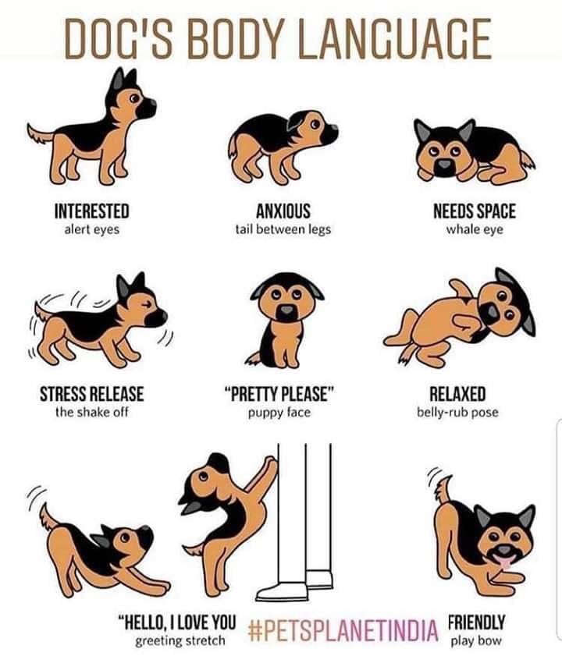
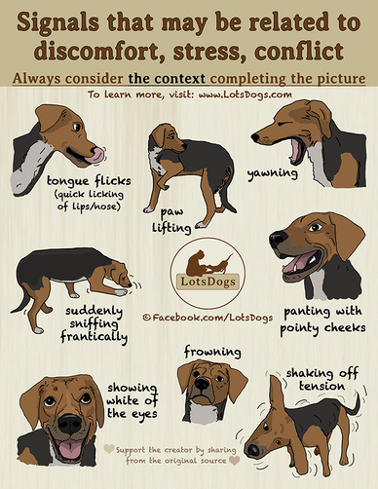

Safety Tips for Cat Handling (from animalsheltering.org)

- Greet the cat while in the kennel setting before lifting it out.
- Speak to the cat in a calm and soothing manner. If the cat appears friendly, open the kennel door quietly. Slow, calm, deliberate movements are best introductions to cats.
- Do not force a cat to interact with you. Cats are finicky and tolerate interaction on their own terms.
- Do not wake a sleeping cat. It is important that we enable our animals to get plenty of rest to sustain good behavior and health.
- After greeting, lift its total body and put him up to your chest area. Place one arm under his body, while using the other to pet him and support its sides.
- Do not allow caged cats on the floor of the shelter. This poses a disease risk to the cat, as well as, overwhelms the cat due to the amount of traffic in the area. Instead take cats to a quieter area.
- Most cats do not want to be placed on their backs while being held. Different cats like to be pet in different places.
- Take your time with a cat, find out what it likes. The best place to start petting a cat is on its back.
- Place a cat back into his kennel gently, so it does not mind being picked up next time.
- If a cat gets out of your hands, you should move slowly to pick it up. its temperament can change easily if he feels threatened.
- Always ask a staff person if you need extra support. Understanding Human to Cat Communication When visiting with a cat, be aware that you are communicating to the animal with your body, expressions, and voice.
Friendly human gestures include
- Speaking in soothing tones
- Blinking eyes slowly while looking at the cat
- Moving slowly and confidently
- Rubbing fingers together or on a soft surface to create a scratching sound
- A relaxed and exaggerated deep breath
Threatening human gestures include:
- Frenzied, abrupt movements
- Loud, boisterous voices
- Rough petting, handling

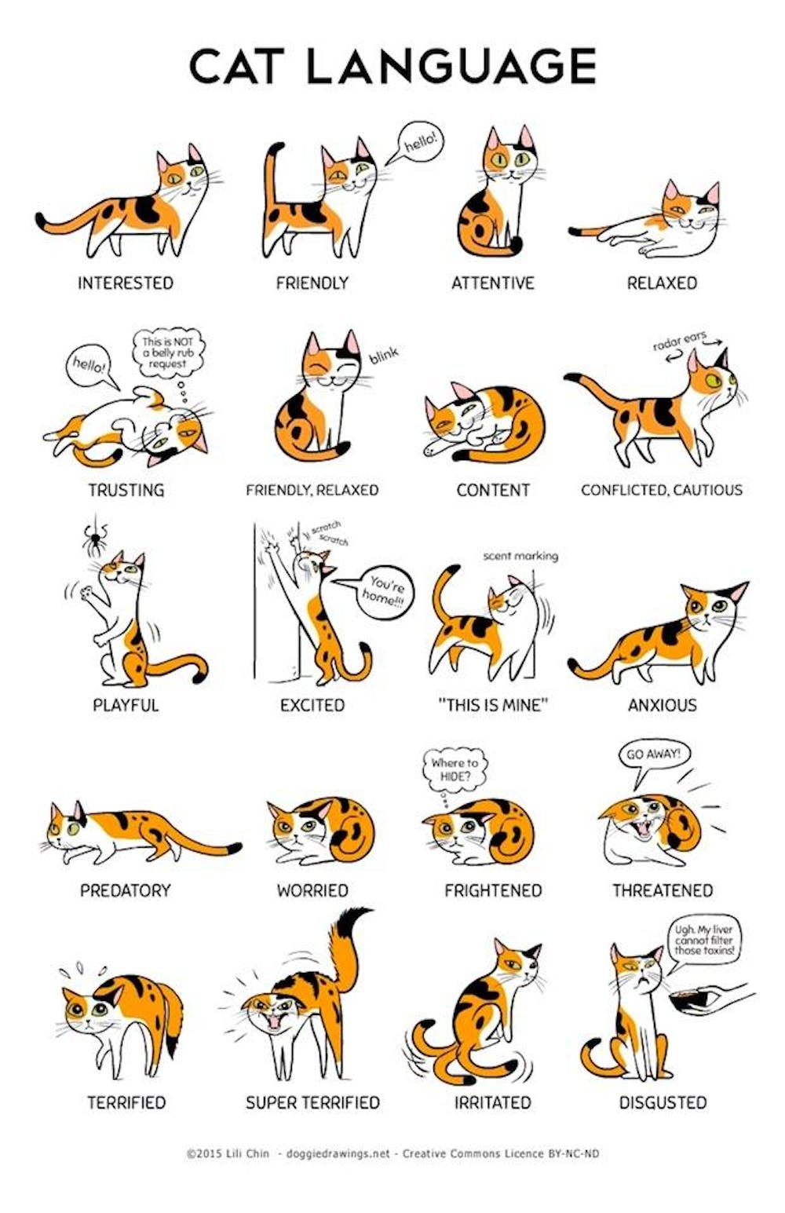
MEDICAL CONSIDERATIONS FOR RESIDENT ANIMALS
Many volunteers have companion animals in their homes. Please do not bring your own animals to the center. Although it is unlikely that you could transmit a virus to your resident animal, we recommend that you consult your veterinarian for recommended vaccinations, which may be as follows:
DOGS: DHLPP Distemper, Hepatitis, Leptaspiarosis, Para influenza, Parvovirus, BORDETELLA: Kennel Cough,
CATS FELV: Feline Luekemia Virus, FRCP Feline Rinotracheltis, Calicivirus, Panleukopenia
RABIES for both Dogs and Cats
ZOONOTIC DISEASES
What is a zoonotic disease?
A zoonotic disease is something than can be transmitted from animals to human beings. Potential agents of zoonotic disease transmission include fungi, bacteria, viruses, parasites and arthropods.
Types of zoonotic diseases include, but are not limited to: Campylobacteriosis Giardasis, Hookworm, Roundworm, Salmonellosis, Toxoplasmosis, Ringworm, Scabies, Barteonellosis (cat scratch fever) Bordetellosis, Pasteurella, Rabies, Leptospirosis
What you can do to prevent zoonotic diseases:
1.) Wash your hands thoroughly after handling any animal.
2.) Prevent animal waste from building up in the environment.
3.) Wear gloves when cleaning up feces.
Special considerations for immunocompromised people:
Zoonotic diseases may be more severe for immunocompromised people. People at increased risk include people with AIDS, people on chemotherapy or being treated for immune mediated disease, people with organ or bone marrow transplants, the elderly, the very young and pregnant women. If you are, or suspect you are, immunocompromised, consult your physician before deciding to volunteer with animals.
ANIMAL DISEASES
CANINE DISTEMPER
Similar to the human Measles virus, this is the most commonly known infectious disease of the nervous system in dogs. This highly contagious, often fatal virus is excreted in the saliva, respiratory secretions, urine, and feces and is transmitted through the air (sneezing and coughing) and by contaminated objects (in the same way a cold virus spreads in people).
Symptoms: loss of appetite, yellowish diarrhea, difficulty breathing, seizures, behavior changes, weakness, thick discharge from the eyes and nose, sometimes thickened cracked footpads.
CANINE PARVOVIRUS
A highly contagious and often lethal virus. Can affect dogs of any age, however, puppies are the most susceptible. The virus is shed in the droppings of infected dogs, and the disease is spread by direct contact with the infected material. Dogs are usually infected when they swallow the virus after licking contaminated material. Direct dog-to-dog contact isn’t necessary to spread the disease. The virus can be picked up simply by walking through a yard contaminated with infected feces or by contact with kennels or other objects that have been contaminated by an infected animal. Your pet could be exposed to the virus from your shoes after you’ve walked through an infected area. The virus is resistant to most common disinfectants and household detergents, but thorough cleaning with household bleach will kill the virus; a dilution of one part bleach to thirty parts water is recommended. Following exposure, symptoms usually occur in five to eleven days. Some puppies suffer sudden death, or succumb with retching, convulsions, or foaming at the mouth; more typically, puppies and adults suffer anorexia, bloody diarrhea, and vomiting with fever.
KENNEL COUGH
Canine Infectious Tracheobronchitis, generically referred to as Kennel Cough, is a highly contagious and common condition affecting dogs. This disease causes an inflammation of the dog’s larynx, trachea, and bronchi (tubes leading to the lungs). All dogs are susceptible, but the disease is most common in dogs exposed to crowded conditions, such as kennels (hence, the name), shows, or other stressful conditions. The disease can be caused by any one or a combination of several different infectious agents. The most common culprits are bacteria called Bordetella bronchiseptica, the canine para-influenza virus, and the canine adenovirus-2. Infection is spread through the saliva and nasal secretions and may occur by direct nose-to-nose contact. However, coughing also transmits the agents through the air from one dog to another. Signs develop four to six days following exposure. Symptoms: Chronic, high pitched, honking cough prompted by excitement, drinking, or pressure against throat. Occasionally, eye or nasal discharge, slight fever, or loss of appetite.
RABIES
Rabies causes a devastating neurological disease that affects the brain, causing symptoms that are similar to meningitis. Once symptoms develop in animals, the disease is always fatal. Infection requires direct contact with an infected animal. The usual transmission is through a bite that introduces infective salivia into the wound. There, the virus proliferates until it reaches the nerves, which carry the infection to the spinal cord. Ultimately, the virus reaches the brain, whereupon symptoms develop. Animals are thought to be infectious only shortly before and during the time they show symptoms. Therefore, a biting animal capable of transmitting disease at the time of the bite will typically develop signs within a ten-day period. For that reason, ten days is the recommended period of quarantine. Symptoms: Refusal to eat or drink, hiding, depression, drooling, throat paralysis, inability to swallow, vicious, violent behavior, excessive vocalizing, chewing or eating wood, rocks, or other inedible objects. The rabies virus is sensitive to many household detergents and soaps. Should you or your pet suffer a bite, consult a doctor or veterinarian immediately. The postexposure vaccine available for people is virtually 100 percent effective when administered in the right period of time.
FELINE LEUKEMIA Feline Leukemia is spread from cat to cat in saliva, through bite wounds, by prolonged casual contact (mutual grooming and sharing of food and water dishes and litter boxes) and from infected mothers to their kittens. Most at risk of infection are cats that spend time outdoors and have contact with other cats that may already be infected. This virus is by far the leading cause of cancer in cats, can cause severe anemia, and it incapacitates the immune system making the cat susceptible to a variety of secondary infections.
FELINE CALICIVIRUS/RHINOTRACHEITIS All cats are susceptible to infection, but as with most other infectious diseases, youngsters tend to get the sickest. Sneezing, runny eyes and nose, fever, and loss of appetite are typical symptoms. Rarely an infected cat will come down with pneumonia, and some cats develop ulcers in the mouth or nose or even on the eye.
FELINE PANLEUKOPENIA Feline Panleukopenia is also known as Feline Distemper. It is a highly contagious and deadly viral disease. Although uncommon, Panleukopenia outbreaks still occur, especially where groups of cats and kittens are housed together. The disease is spread by direct contact with infected saliva, urine, vomit, or feces, or indirectly through contact with contaminated objects. If you think that you or your animal has been exposed to a disease, please consult your doctor and/or veterinarian for appropriate treatment.

Things to Remember
1. It is extremely important to understand that our hands, clothing and shoes are the greatest threat to animals in our shelter. Always wash your hands thoroughly and use hand sanitizer if you are moving from animal to animal. Holding an animal against your clothing can spread disease to the next animal you hold. Wrapping an animal in a towel and changing towels between each will offer protection. Should you be required to go into an isolation ward, be sure to stand in the foot bath prior to leaving the room. Animals are very susceptible to illness in a kennel environment. Even though they receive inoculations when they enter the SPCA, often this is the only inoculation they have ever received and it takes time to build up their immune systems.
2. Make sure to use the techniques you are taught for opening kennels and handling the animals.
3. When returning an animal to its cage, make sure the door is securely closed. Improperly closing doors can result in serious injury, possibly death, to one of the animals.
4. Do not handle an animal with which you are not comfortable. Animals sense hesitation and fear and act upon it.
5. If you witness anyone mistreating an animal (staff or another volunteer) report it to the front desk immediately!
6. If a cage is marked DO NOT OPEN, please do NOT open it. This means that the animal is quarantined for health issues and if they are accidentally released, others are in danger.
7. Above all else, have fun, be safe, and help our SPCA animals by giving them the love and attention they deserve

